
DHARMSINH DESAI UNIVERSITY, NADIAD
FACULTY OF MANAGEMENT AND INFORMATION SCIENCE
B.C.A. SEMESTER VI
SUBJECT: (25BCA601)SYSTEM DEVELOPMENT PROJECT
Student Name | Himanshu D Ladha
Roll No | BCA045
Student ID | 23BCUOS055

Project Definition: RestoFlow – A full-stack Restaurant Management Platform.

Company Timing: 11:00 AM to 6:00 PM

Week | Date | Day | Name of the Topic | Signature
Sixth Week | 05-01-2026 | Monday | Otp based login implementation
Sixth Week | 06-01-2026 | Tuesday | Code review and Authentication flow understanding
Sixth Week | 07-01-2026 | Wednesday | Payment Integration understanding
Sixth Week | 08-01-2026 | Thursday | Backend of the stripe payment
Sixth Week | 09-01-2026 | Friday | Frontend of the stripe payment

External Guide Name: Internal Guide Name: Prof. Rupal Patel
Signature Signature

05-01-2026
- Implemented OTP-based login functionality.
- Altered the Users table in the database to add an OTP column for storing OTP values.
- The OTP is displayed on the frontend and simultaneously stored in the backend database for verification.
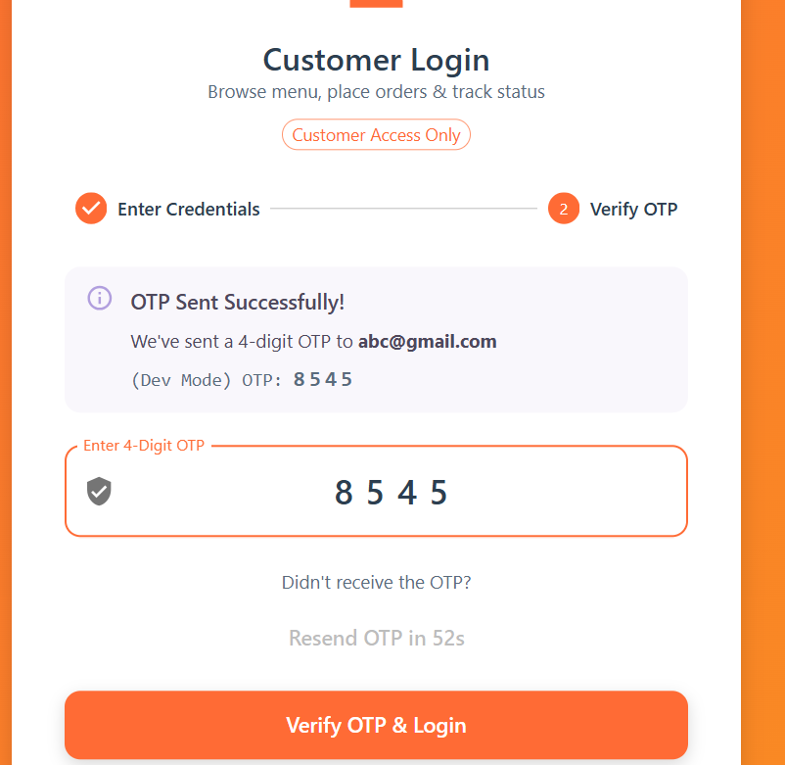
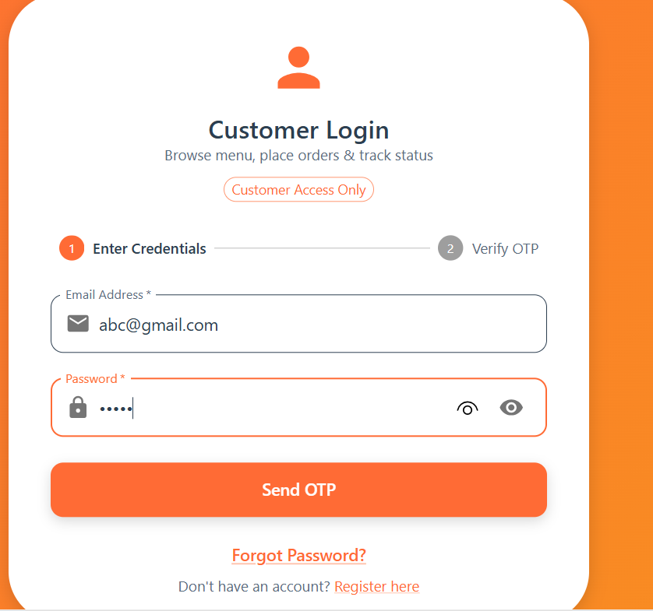
06-01-2026
- Made necessary modifications to the existing codebase.
- Reviewed and understood the authentication implementation.
- Created a structured understanding table for:
  - authApi (Frontend API layer)
  - axiosConfig (Axios configuration and interceptors)
  - AuthController (Backend authentication logic)
07-01-2026
- Gained a clear understanding of the frontend Home page concept.
- Learned and understood the fundamentals of payment integration.
- Attempted to implement the payment integration
08-01-2026
- Created the backend portion of the payment using the stripe account
09-01-2026
- Created the frontend portion of the payment

